KONTROL MOTOR DC BERBASIS ARDUINO IMPLEMENTASI PADA MOTOR PENGGULUNG & PENGARAH

- Tujuan:
Mampu mengimplementasikan prinsip kerja motor DC berbasis arduino pada motor penggulung dan pengarah.
- Alat dan bahan:
1. PC/Laptop dengan software arduino (1 set)
2. Power supply (1 buah)
3. Modul Driver Motor (2 set)
4. Arduino Nano (1 buah)
5. Kabel Wiring (Secukupnya)
6. Kabel USB (1 buah)
7. Kabel power/Secker (1 buah)
8. Limit Switch roller (2 buah)

- Setting percobaan:
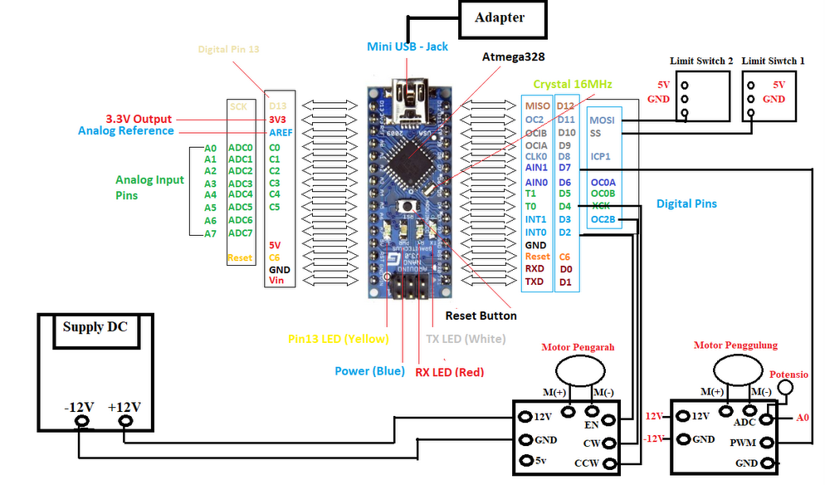
- Prosedur percobaan:
- Menyiapkan peralatan yang dibutuhkan
- Menghubungkan mini USB jack arduino ke adapter atau port USB pada PC lalu pilih Arduino Software.
- Menghubungkan power supply dengan kabel power ke sumber listrik AC.
- Menghubungkan power supply dengan kedua input motor (pengarah dan penggulung) secara pararel.
- Konfigurasikan kabel sesuai gambar setting percobaan. Atau perhatikan tabel berikut:
I/O |  | Pin Arduino
Input | LS1 | D10
Input | LS2 | D11
Input | Potensio | A1
Output
Motor 1 | En/PWM | D6
Motor 1 | CW | D7
Motor 1 | CCW | D8
Motor 2 | En/PWM | D3
- Have fun ☺
- Rangkaian & Source Code
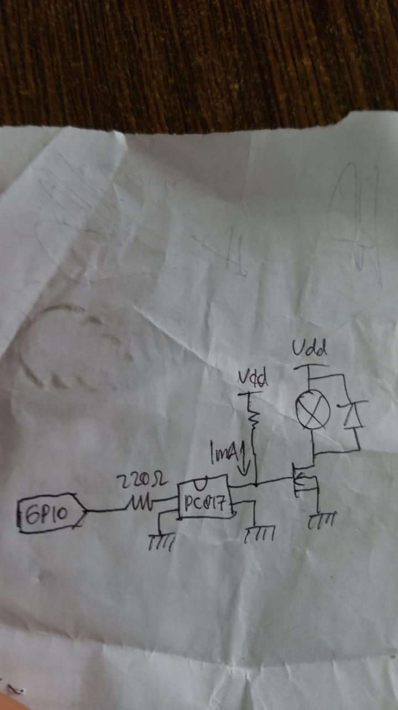
Gambar 1. Rangkaian Driver Motor Penggulung
Bahan:
Resistor 220 ohm, R 1K ohm, PC817 (optional), RFP30N06LE, diode 1A, pin male female header secukupnya, dan kabel secukupnya.
Rangkai bahan diatas sesuai rangkaian pada gambar 1. Lakukan troubleshooting pada kabel dan jalur rangkaian.

Source code: berikut lampiran source code dari per sub bagian s/d source code sistem total.
Lampiran
koding read analog potensiometer
int potPin = A0; // select the input pin for the potentiometer
//int ledPin = 13/; // select the pin for the LED
int val = 0; // variable to store the value coming from the sensor
int en=7;

void setup() {
Serial.begin(9600);
pinMode(en, OUTPUT);
}

void loop() {
val = analogRead(potPin); // read the value from the sensor
////// digitalWrite(ledPin, HIGH); // turn the ledPin on
delay(val); // stop the program for some time
Serial.println(val);
analogWrite(en,val);
}
koding limit switch kanan kiri
int ls1=10;
int ls2=11;
void setup() {
// put your setup code here, to run once:
pinMode(ls1,INPUT);
pinMode(ls2,INPUT);
Serial.begin(9600);
}
void loop() {
// put your main code here, to run repeatedly:
if (digitalRead(ls1)==LOW) Serial.print("Tombol ls1 ditekan");
if (digitalRead(ls2)==LOW) Serial.print("Tombol ls2 ditekan");
Serial.println("");
delay(500);
}
koding motor penggulung
//Motor penggulung
int en1 = 7; // en motor penggulung
int pot=A0;
int V=0;

void setup() {
// put your setup code here, to run once:
Serial.begin(9600);
pinMode(en1, OUTPUT);
}

void loop() {
// put your main code here, to run repeatedly:
V=analogRead(pot);
Serial.println(V);
analogWrite(en1,V);
}
koding motor pengarah
//Motor pengarah kanan kiri
int en1 = 2;
int motor1M = 3; // pin on L29D untuk maju
int motor1m = 4; // pin on L298D u/ mundur
int V=0;
int Vkal=100;
int pot1=A0;
int ls1=10;
int ls2=11;
void setup() {
// put your setup code here, to run once:
Serial.begin(9600);
pinMode(en1, OUTPUT);
pinMode(motor1M, OUTPUT);
pinMode(motor1m, OUTPUT);
pinMode(ls1,INPUT);
pinMode(ls2,INPUT);
kalibrasi_motor();
}
void loop() {
// put your main code here, to run repeatedly:

V=analogRead(pot1);
Serial.println(V);
if (!digitalRead(ls1))
{
digitalWrite(motor1m, LOW);
digitalWrite(motor1M, HIGH);
analogWrite(en1,V);
Serial.println("Tombol ls 1 ditekan");
}

if (!digitalRead(ls2))
{
digitalWrite(motor1m, HIGH);
digitalWrite(motor1M, LOW);
analogWrite(en1,V);
Serial.println("Tombol ls 2 ditekan");
}
}
void kalibrasi_motor()
{
while (digitalRead(ls1))
{
analogWrite(en1,Vkal);
Serial.println("Kalibrasi menuju ls1");
digitalWrite(motor1m, HIGH);
digitalWrite(motor1M, LOW);
}
Serial.println("kalibrasi selesai, motor berhenti!.");
}
Berikut merupakan koding robries 1 sistem utuh.
//Motor pengarah kanan kiri
int en1 = 6;
int motor1M = 7; // pin on L29D untuk maju
int motor1m = 8; // pin on L298D u/ mundur
int en2 = 3; // en motor 2 penggulung
int V1=0,V2=0; // variable to store the value coming from the sensor
int V=0;
int Vkal=200;
int pot1=A1;
//int pot2=A1;
int ls1=10;
int ls2=11;

void setup() {
// put your setup code here, to run once:
Serial.begin(9600);
pinMode(en1, OUTPUT);
pinMode(motor1M, OUTPUT);
pinMode(motor1m, OUTPUT);
pinMode(ls1,INPUT);
pinMode(ls2,INPUT);
pinMode(en2, OUTPUT);
kalibrasi_motor();
}

void loop() {
// put your main code here, to run repeatedly:
V1=analogRead(pot1);
V=V1/3;
analogWrite(en2,V1);
Serial.println(V1);
if (!digitalRead(ls1))
{
digitalWrite(motor1m, LOW);
digitalWrite(motor1M, HIGH);
analogWrite(en1,V);
Serial.println("Tombol ls 1 ditekan");
}
if (!digitalRead(ls2))
{
digitalWrite(motor1m, HIGH);
digitalWrite(motor1M, LOW);
analogWrite(en1,V);
Serial.println("Tombol ls 2 ditekan");
}
}
void kalibrasi_motor()
{
while (digitalRead(ls1))
{
analogWrite(en1,Vkal);
Serial.println("Kalibrasi menuju ls1");
digitalWrite(motor1m, HIGH);
digitalWrite(motor1M, LOW);
}
Serial.println("kalibrasi selesai, motor berhenti!.");
}

